GUJARAT UNIVERSITY


Project report on
< // Student Counselling Mind // >
DEVELOPED BY:

PRIYANSHU JANI (202126940033)
SARNA KARANDEEP SINGH (202126940109)
NITIN PARMAR (2021269400711)
NOUMAN MANSURI(202126940049)

MSc.IT Data Management and visual insight (5 years Integrated)
(Sem-3) Department of Animation, Gujarat University Academic year
2022-2023
Internal Guide – Ms. Neepa Mandalia

Acknowledgement

- This project was developed under the guidance of our HOD Roshni Vyas and our mentor Neepa Mandalia in accordance with our curriculum in order to acquire practical and industrial knowledge in the field of Data Science.

- The purpose of this website is to provide students who are unsure of what to do after high school or in which field they would have a bright future based on their interests with the best guidance and advice possible. By doing so, we will point them in the right direction in accordance with their desires.

- Another reason for doing so is to eliminate any doubts or difficulties they may have regarding their graduate education. We designed these websites for all students desiring career guidance because many students are capable of building bright futures and have strong academic credentials but were unable to do so due to a lack of direction and insufficient knowledge.

Table Of Content of the Student Counselling Mind.

Number | Description | Page No.
1 | Introduction | 4
 | - Project summary | 4
 | - Propose | 5
 | - Project Scope | 5
 | - Tools And Technology | 6
2 | System Planning & Analysis | 7
3 | Feasibility Study | 11
4 | System Design | 10
 | - DFD | 12
 | - Data Dictionary | 14
 | - Screen Layout | 15
5 | Testing | 21
 | - Test Cases | 22
6 | Conclusion | 23
7 | Future Enhancement | 24
8 | References and Bibliography | 24

INTRODUCTION: -

- Student Counselling Mind is done for many reasons. We all have created this website to help the student. We have kept many courses in this website.
- In this website introduces first-time distance learners to the realities of Web-based education and serves as the most comprehensive, practical guide to achieving success when facing online-specific barriers as well as common academic hurdles.
- Written by an experienced instructor, this invaluable aid shows students how to overcome challenges related to e-mail communication, technological catastrophes, staying organized on a daily basis, and more.

PROJECT SUMMARY: -
- Students learn to take advantage of the unique resources available for those enrolled in internet-based programs and to make the most of their Web-based educational experience by tailoring it to their personal strengths, needs, and learning styles.
- Students were very easily to go and check this website for better knowledge. This website is help to check, which courses is best for students.
- In this website there are many courses like: - Science, Commerce, Arts, BSC, BCA, B.COM, M.COM, BBA, MBA, etc.
- In this website will be help for 10th, Diploma, 12th students to choose their courses in which they want to go. What kind of students do you want or what kind of students don’t you want.

PURPOSE: -
- We are creating this website for helping a student. We know about Lots of website are in the market but, in this website, we are created lots of facility.
- The student bears the responsibility of engaging with the course instead of simply showing up to class on an assigned day and time. As a result, students not only gain knowledge from the coursework, but they also sharpen their time management skills.
- Through online courses, students can gain the knowledge they need to earn their degree or grow in their profession.
- In this website we are given for students to know about this opportunity to develop knowledge and skills through engaging projects set around challenges and problems they may face in the real world.

PROJECT SCOPE: -
- We are creating this website for students. In the modern age, access to information is the key to professional success. Gone are the days when education and learning were confined to colleges and universities. In the digital age, learning is open to all.
- All over world students are highly enthusiastic about the concept of online education. They get a chance to showcase their skills and capabilities in an interactive and advanced environment.
- In this website we are provides a wide range of courses that caters to the core interests of the student, thus creating a fertile arena for future advancement.

System Analysis

Project Profile
Project Title : Student Counselling Management
Project definition : This is a student consult website where student can find their respective information about the courses and gain freedom to choose the different courses. All different types of courses are there to choose from and to learn which can be done after their respective course.
Project Developers : Sarna Karandeep Singh
Priyanshu Jani
Nitin Parmar
Nouman Mansuri
Project Duration : September 2022 to December
Project Platform : Windows 10 , 7, 11, XP
Study Centre : Department of Data management. Gujarat University

System Planning

- Stu Cons Mind is a counselling website to provide the information about different type of courses.
- The user can see different type of courses according to their courses type or their undergoing courses.
- Also, they can gain knowledge and information about the courses they are viewing.
- The purpose of the student Cons Mind is to provide the information and seminars about the counselling and knowledge about different courses.

Hardware & Software Specification
- System Requirement Specification is basically an organization understanding (in writing) of a customer or potential client’s system requirements and dependencies at a particular point in time (usually) prior to any actual design or development work. The SRS also functions as blue print for completing a project with as little cost growth as possible. A well-designed well-written SRS accomplishes the following major goals:
- It decomposes the problem into component parts.
- Its services as an input to the design specification.
- It serves as a product validation check
- System requirement specification includes following requirement specification for this project:
- Hardware Requirement Specification
- Software Requirement Specification
TOOLS AND TECHNOLOGY: -
- We are using this type of technology like: -
- In Frontend: -
- HTML
- CSS
- JAVA SCRIPT
- In Backend: -
- PHP
- MYSQL

Hardware Requirement Specification
Any Personal Computer with following hardware configuration:
Developer Requirement:
Os : Windows Xp or More
Processor : Intel Core version 2 GHz or more
RAM : 2 GB or more
Hard Disk : 60 GB or more
Internet : 1 Mbps network bandwidth or more
Software Requirement Specification:
Frontend : HTML, CSS
Backend : MySQL
Scripting Language : PHP
Server : Apache Server (XAMPP)
IDE : VS Code, Atom

Feasibility study

System Design
- Data Flow Diagram Level – 0 and Level- 1
- Data Dictionary
- Screen Layout
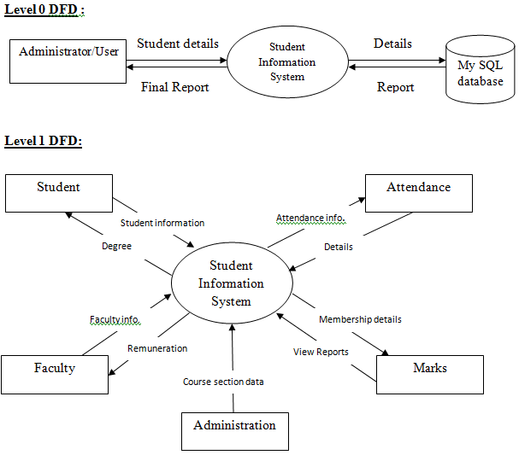

Data Dictionary

Login Table
NO | Title | Datatype | Size
1 | rno | int | 20
2 | username | string | 10
3 | password | Int, charcter | 8-10

Registration page
NO | Title | Datatype | Size
1 | email | Int,string,character | 20
2 | username | string | 10
3 | password | Int, charcter | 8-10

SCREEN LAYOUT’S

Home page



Information Page

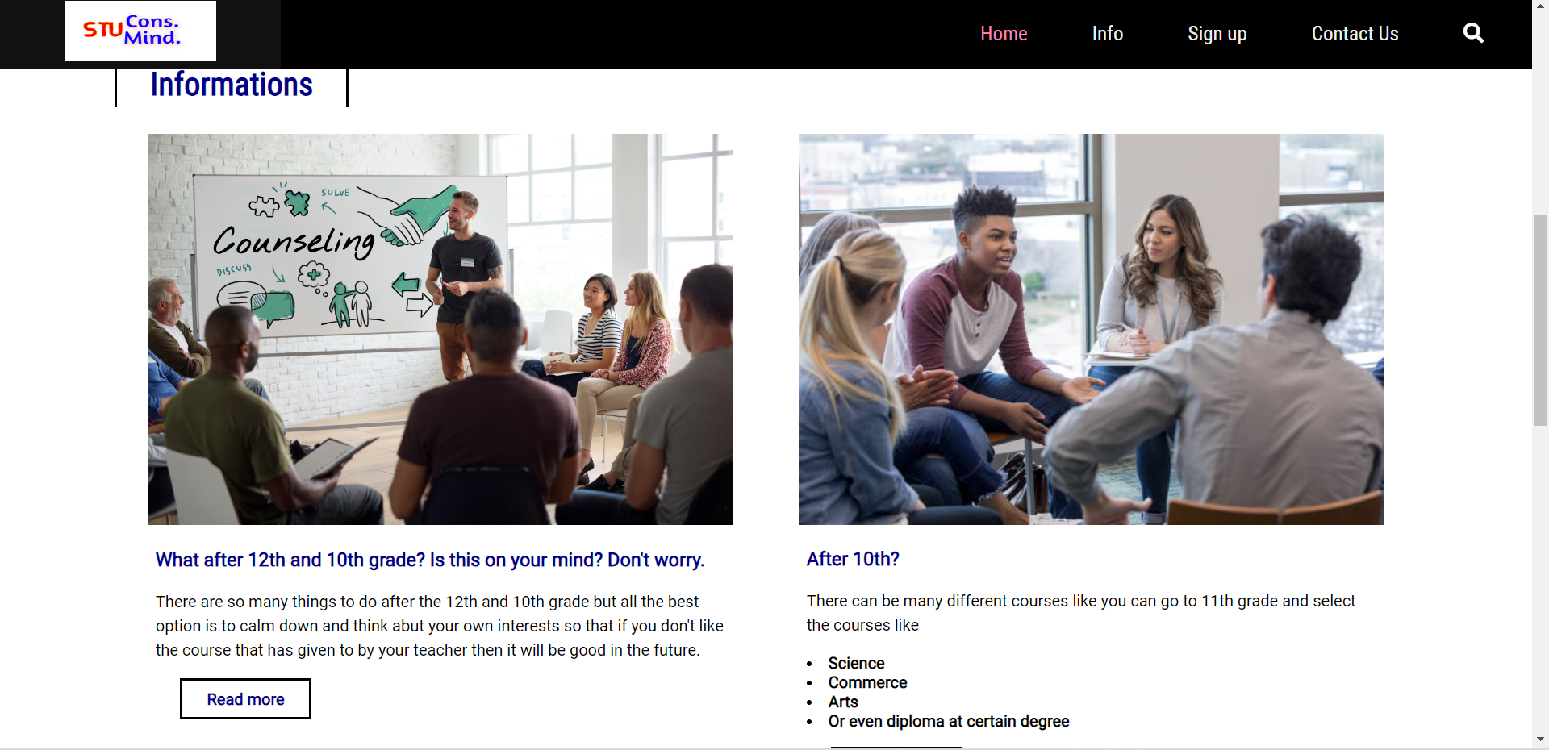

Quick Links
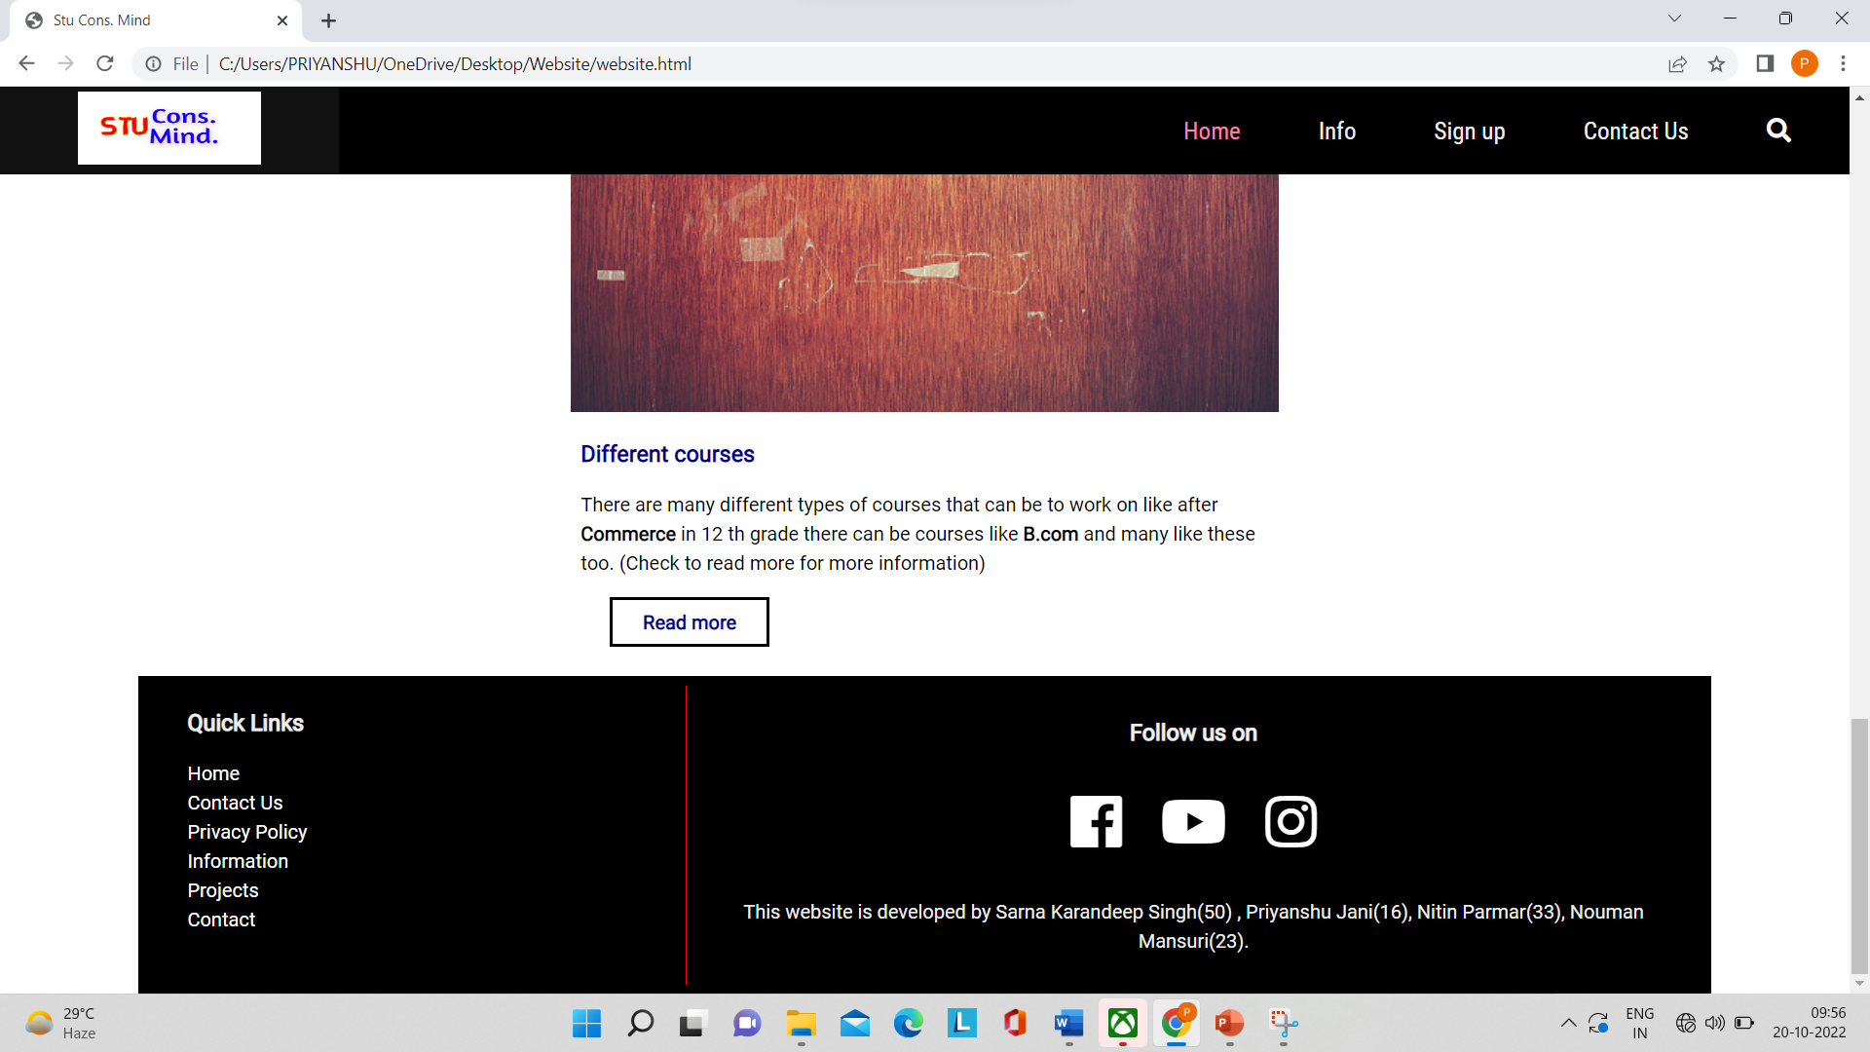
Sign up page
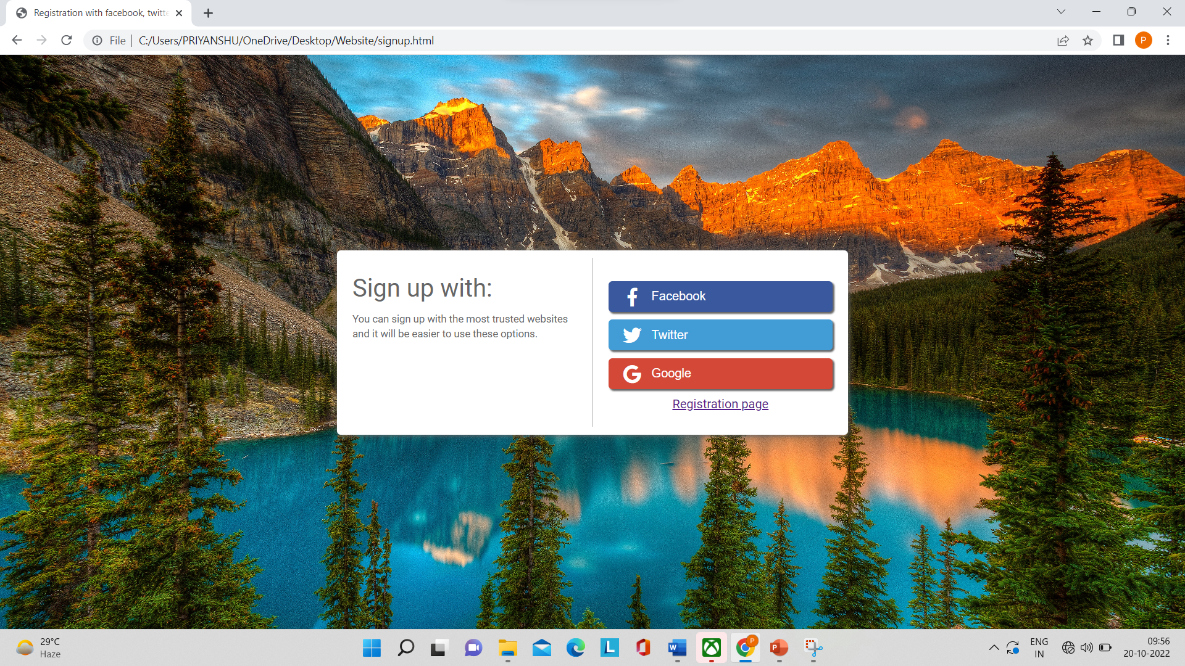
Registration page
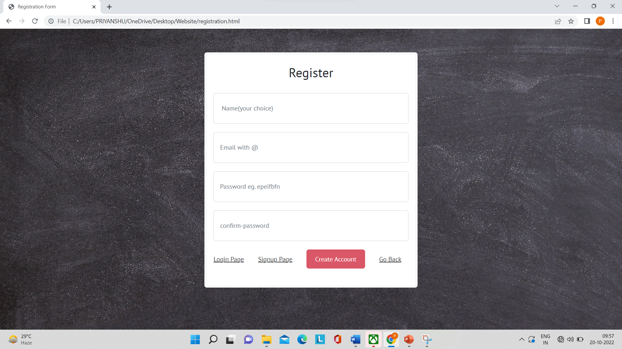

Login Page

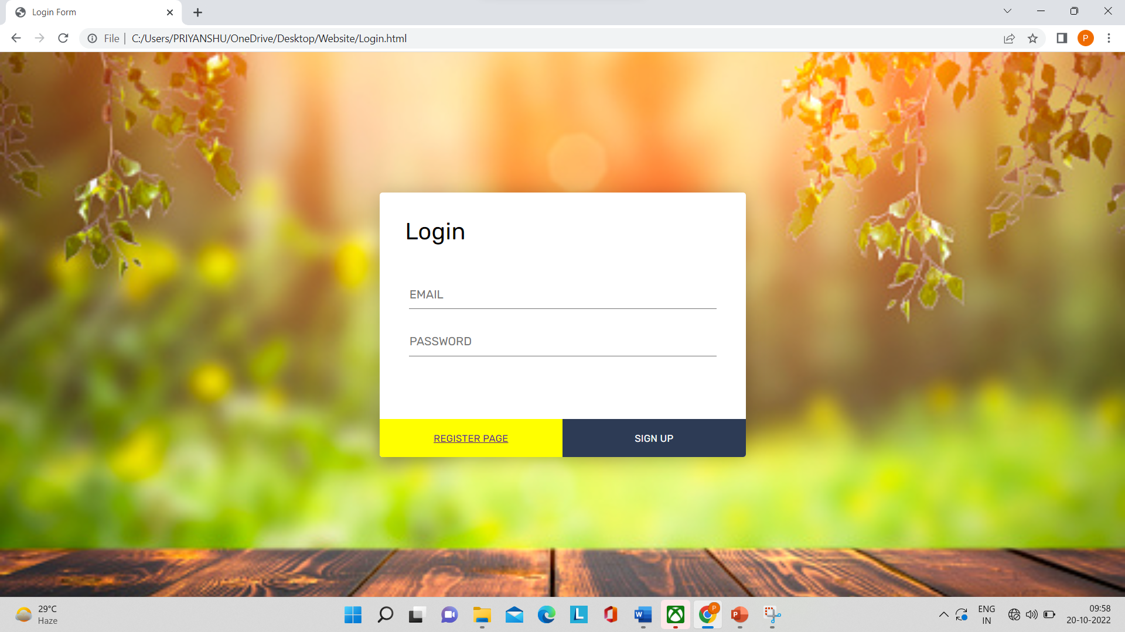

Test Cases

No. | Title | Expected Result | Actual Result | Solution | Status
1 | Information page | Images and text should be in proper alignment. | Text and image has not proper alignment | Putting cards instead of images | Success
2 | Registration Page Background image | Images should be dark | Image are very bright | Decrease brightness | Success
3 | Home page & Registration page | Easily go back to home page from registration page | Not working properly | Add Button in Registration page to  Go Back to home page. | Success
4 | Home page | Background image should be steady while scrolling. | Background image of home | Use banner attribute for proper result. | Success

Conclusion

- The Main Points Of This Websites Is Student Council Ideas Provides Opportunities For Choosing An Interested Course And Go To Right Way Of Golden Carrier Opportunities.

- The purpose for making this website is to solve the problems student has, and to have the new options of courses to focus their future on

- The Purpose of This Website Student Council Is Gives Ideas of Development, Leadership And Carrying Out What After High School? (After 12th).

- The Well-Designed Website Is the Most Important Part of The Website, It Can Help Website to Create Good Impression on Your Purpose of This Website.

- We also get to know many things about learning on how to make websites with the ideas for future that can be beneficial for the user.

Future Enhancement

- We have a lot of idea for the future regarding how to offer counselling to students through a variety of channels, such as hosting webinars and seminar

- Additionally, in the future, we intend to provide one–on-one counselling by setting up meetings with professionals who will lead the client.

- Additionally, we will include a feature that allows users to assist young people.
- We'll set up a chat room on this website so users may ask questions and receive answers by chatting online. This will allow users to obtain help with any problems they may be having or get advice in a certain area.

- Additionally, we will include audio and video sessions so that each user may receive individualised guidance. We will also make sure to construct a safe platform.

- Our premium version of our website is available to users at a reasonable price for those who prefer to receive their counselling personally from qualified counsellors, who can also help them with any questions they may have concerning their careers.

- To ensure that the largest possible audience can find the appropriate route, we intend to create the entire website in practically all of the Indian languages.

Reference bibliography

- There are many different types of References Because there are countless websites like us but some of the references are follows: -
  - YouTube
  - Stud portal
  - Shiksha
  - W3 School
  - Codingir

THANK YOU

